

**Name: Esha asif**

**Roll no:034**

**Section:BSAI 4A**

**Subject:Programming for AI**

**LAB TASK 5**

**Code:**

**2.1**

#2.1

import pandas as pd

import cv2

img = cv2.imread("C:\\Users\\eshaa\\OneDrive\\Desktop\\ewww\\d8cb105b641f3568781f26abda635a7d.jpg", cv2.IMREAD_COLOR)

cv2.imshow("image", img)

cv2.waitKey(0)

cv2.destroyAllWindows()

**Output:**

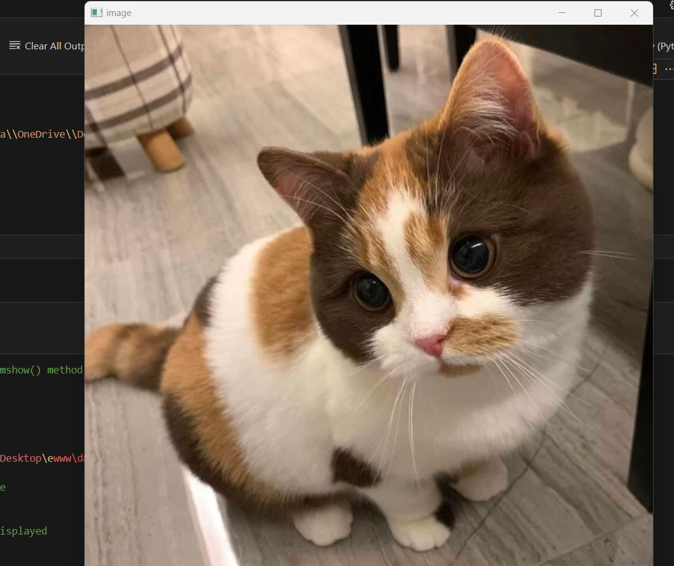

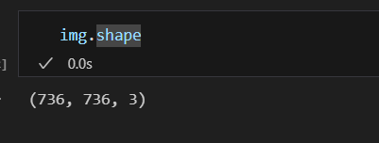

# Python program to explain cv2.imshow() method

# importing cv2

import cv2

# path

path = r'C:\Users\eshaa\OneDrive\Desktop\ewww\d8cb105b641f3568781f26abda635a7d.jpg'

# Reading an image in default mode

image = cv2.imread(path)

# Window name in which image is displayed

window_name = 'image'

# Using cv2.imshow() method

# Displaying the image

cv2.imshow(window_name, image)

# waits for user to press any key

# (this is necessary to avoid Python kernel form crashing)

cv2.waitKey(0)

# closing all open windows

cv2.destroyAllWindows()

**OUTPUT:**

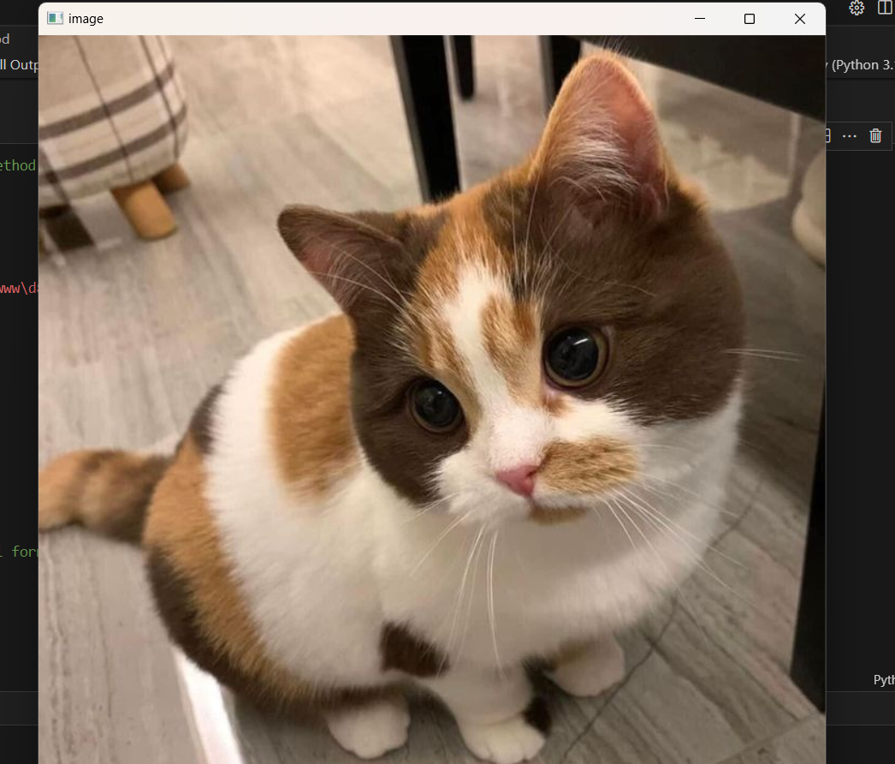

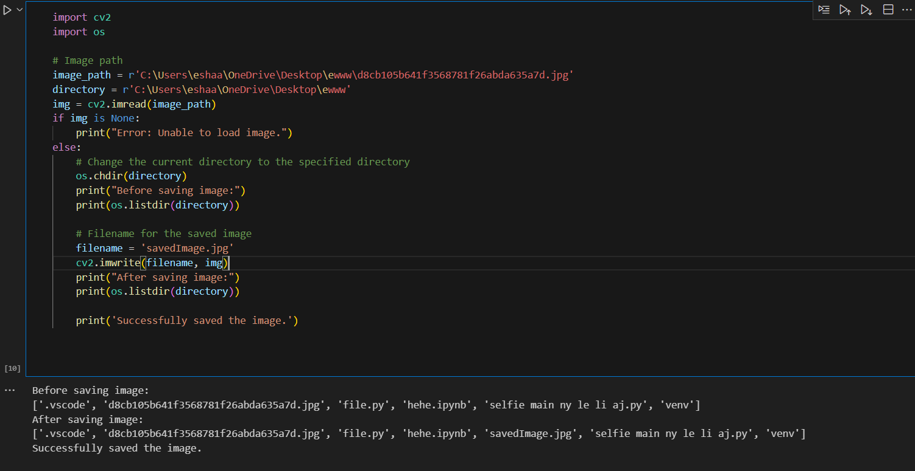

import cv2

image = cv2.imread("C:\\Users\\eshaa\\OneDrive\\Desktop\\ewww\\d8cb105b641f3568781f26abda635a7d.jpg")

B, G, R = cv2.split(image)

# Corresponding channels are separated

cv2.imshow("original", image)

cv2.waitKey(0)

cv2.imshow("blue", B)

cv2.waitKey(0)

cv2.imshow("Green", G)

cv2.waitKey(0)

cv2.imshow("red", R)

cv2.waitKey(0)

cv2.destroyAllWindows()

**Output:**

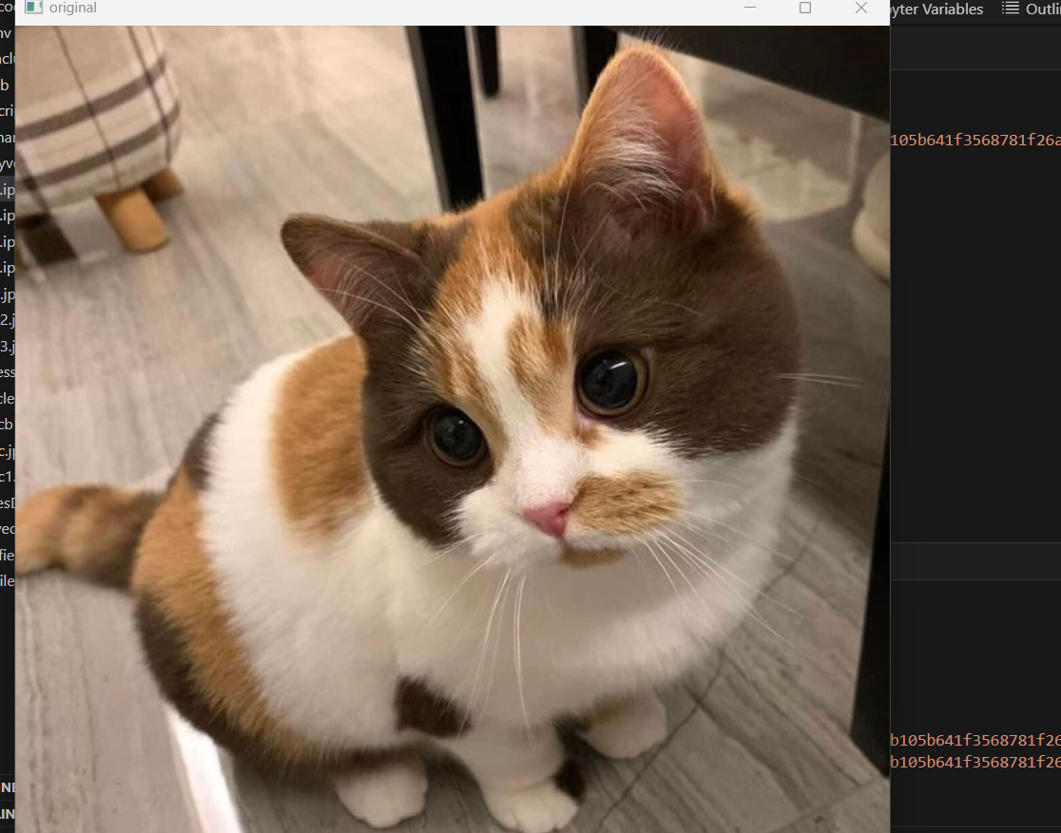

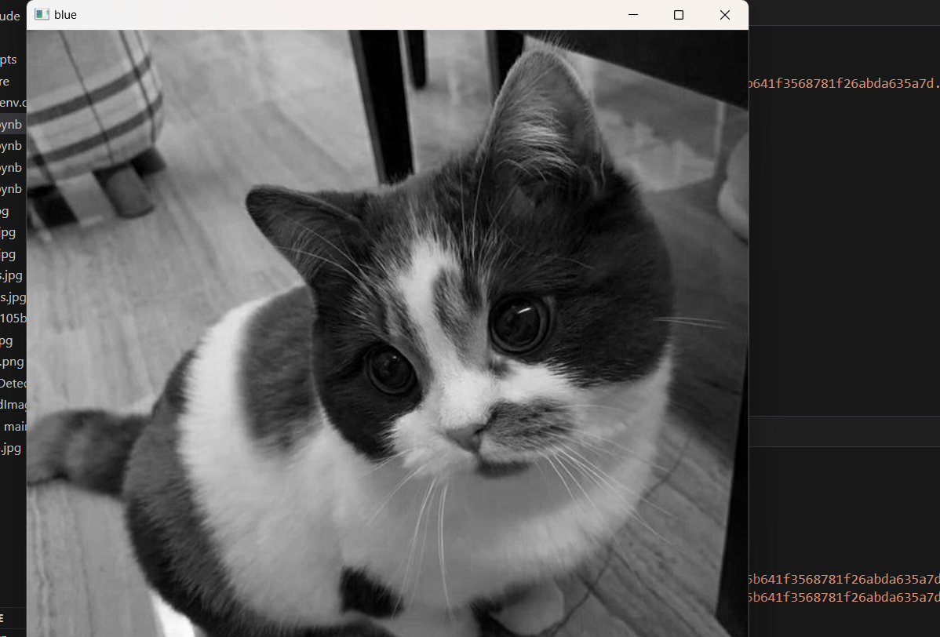

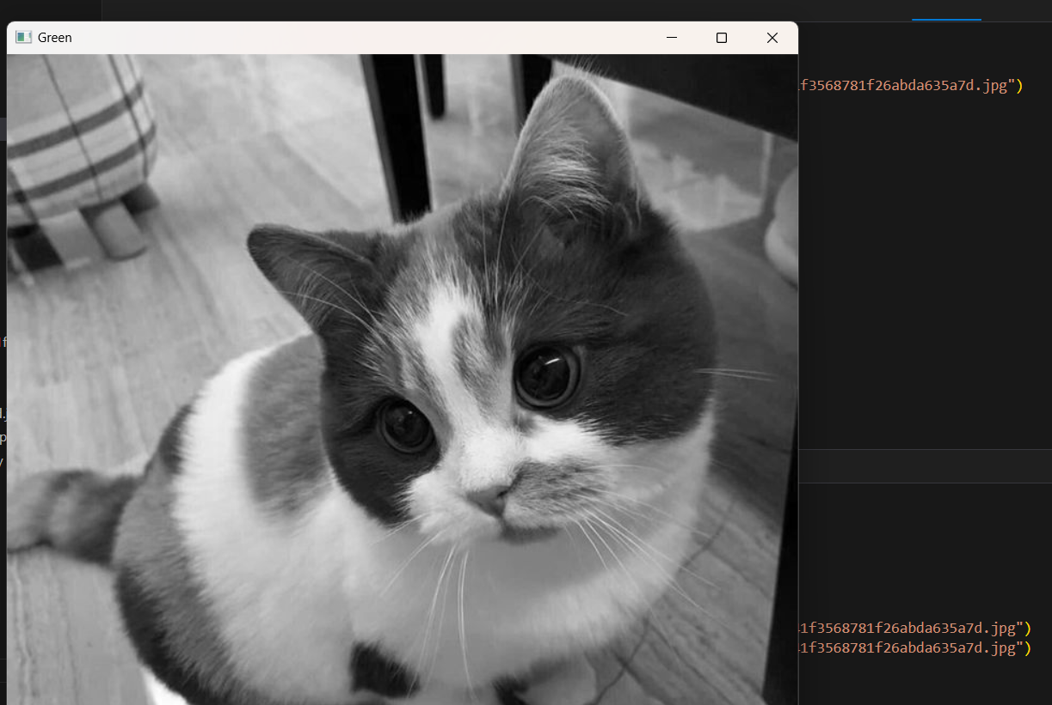

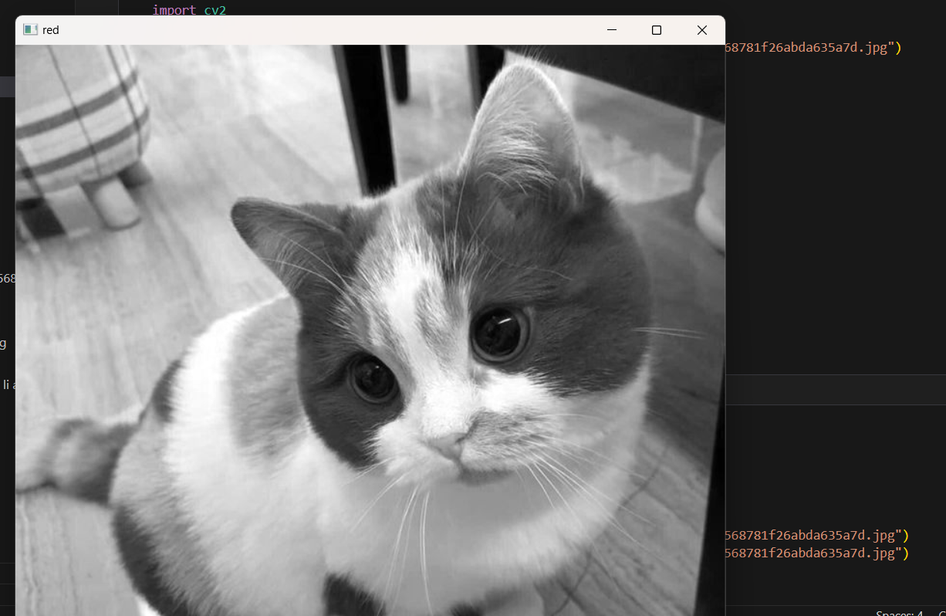

import cv2

import numpy as np

# path to input images are specified and

# images are loaded with imread command

image1 = cv2.imread("C:\\Users\\eshaa\\OneDrive\\Desktop\\ewww\\d8cb105b641f3568781f26abda635a7d.jpg")

image2 = cv2.imread("C:\\Users\\eshaa\\OneDrive\\Desktop\\ewww\\d8cb105b641f3568781f26abda635a7d.jpg")

# cv2.addWeighted is applied over the

# image inputs with applied parameters

weightedSum = cv2.addWeighted(image1, 0.5, image2, 0.4, 0)

# the window showing output image

# with the weighted sum

cv2.imshow('Weighted Image', weightedSum)

# De-allocate any associated memory usage

if cv2.waitKey(0) & 0xff == 27:

cv2.destroyAllWindows()

**OUTPUT:**

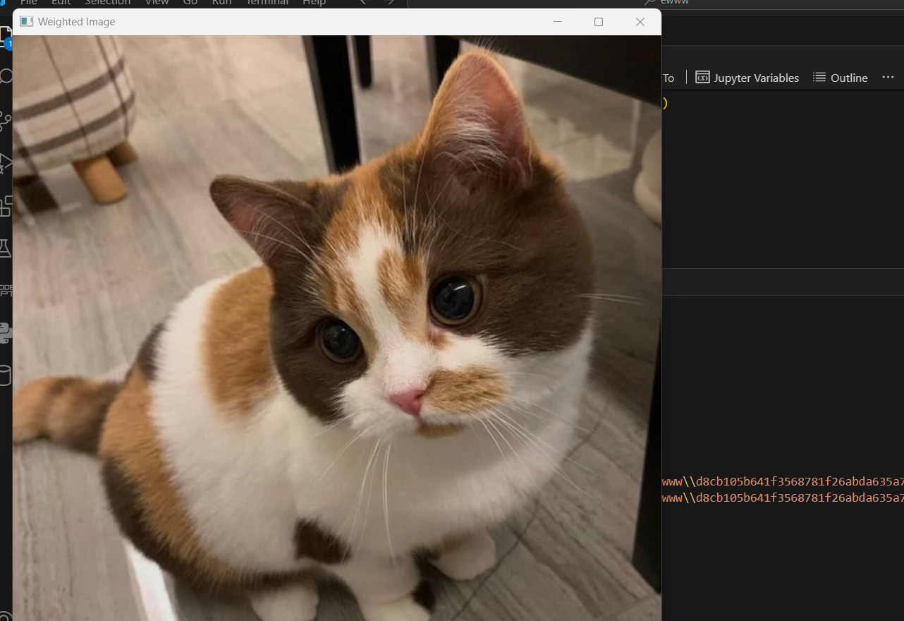

import cv2

import numpy as np

# path to input images are specified and

# images are loaded with imread command

img1 = cv2.imread("C:\\Users\\eshaa\\OneDrive\\Desktop\\ewww\\d8cb105b641f3568781f26abda635a7d.jpg")

img2 = cv2.imread("C:\\Users\\eshaa\\OneDrive\\Desktop\\ewww\\d8cb105b641f3568781f26abda635a7d.jpg")

# cv2.bitwise_and is applied over the

# image inputs with applied parameters

dest_and = cv2.bitwise_and(img2, img1, mask = None)

# the window showing output image

# with the Bitwise AND operation

# on the input images

cv2.imshow('Bitwise And', dest_and)

# De-allocate any associated memory usage

if cv2.waitKey(0) & 0xff == 27:

cv2.destroyAllWindows()

**OUTPUT:**

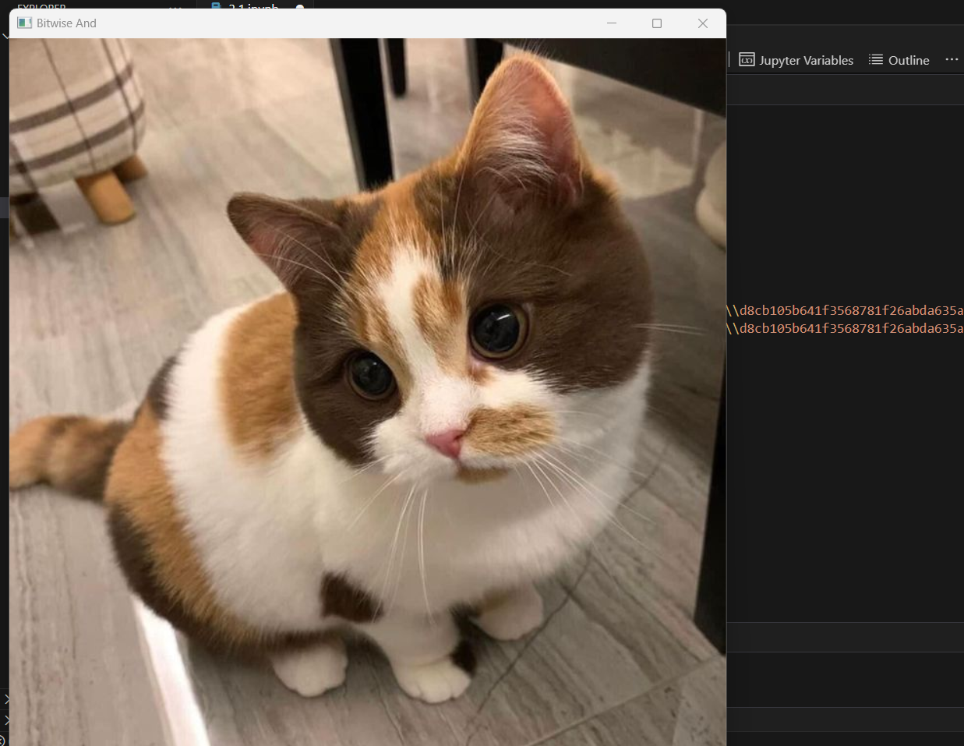

**2.2**

import cv2

import matplotlib.pyplot as plt

image = cv2.imread("C:\\Users\\eshaa\\OneDrive\\Desktop\\ewww\\car.jpg", 1)

# Loading the image

half = cv2.resize(image, (0, 0), fx = 0.1, fy = 0.1)

bigger = cv2.resize(image, (1050, 1610))

stretch_near = cv2.resize(image, (780, 540),

interpolation = cv2.INTER_LINEAR)

Titles =["Original", "Half", "Bigger", "Interpolation Nearest"]

images =[image, half, bigger, stretch_near]

count = 4

for i in range(count):

plt.subplot(2, 2, i + 1)

plt.title(Titles[i])

plt.imshow(images[i])

plt.show()

**OUTPUT:**

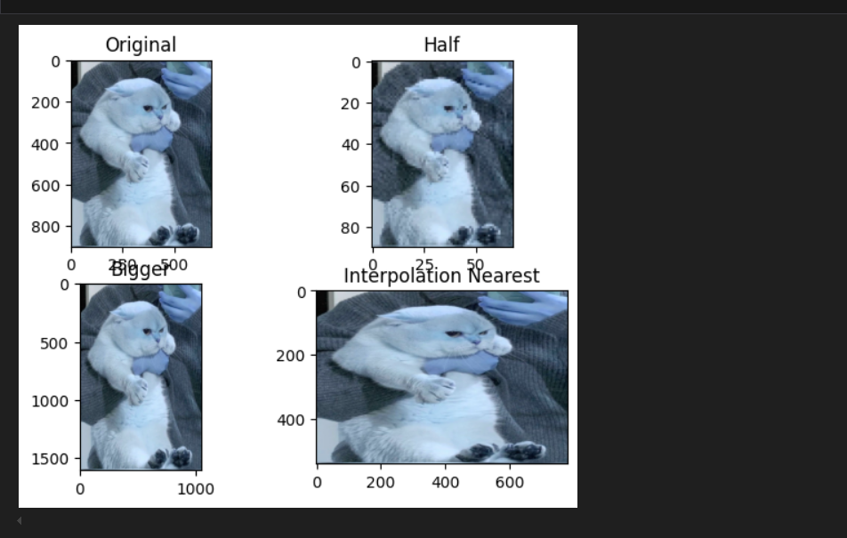

import cv2

# importing numpy

import numpy as np

# path

path = "C:\\Users\\eshaa\\OneDrive\\Desktop\\ewww\\car.jpg"

# Reading an image in default mode

image = cv2.imread(path)

window_name = 'Image'

kernel = np.ones((5, 5), np.uint8)

# Using cv2.erode() method

image = cv2.erode(image, kernel)

# Displaying the image

cv2.imshow(window_name, image)

**OUTPUT:**

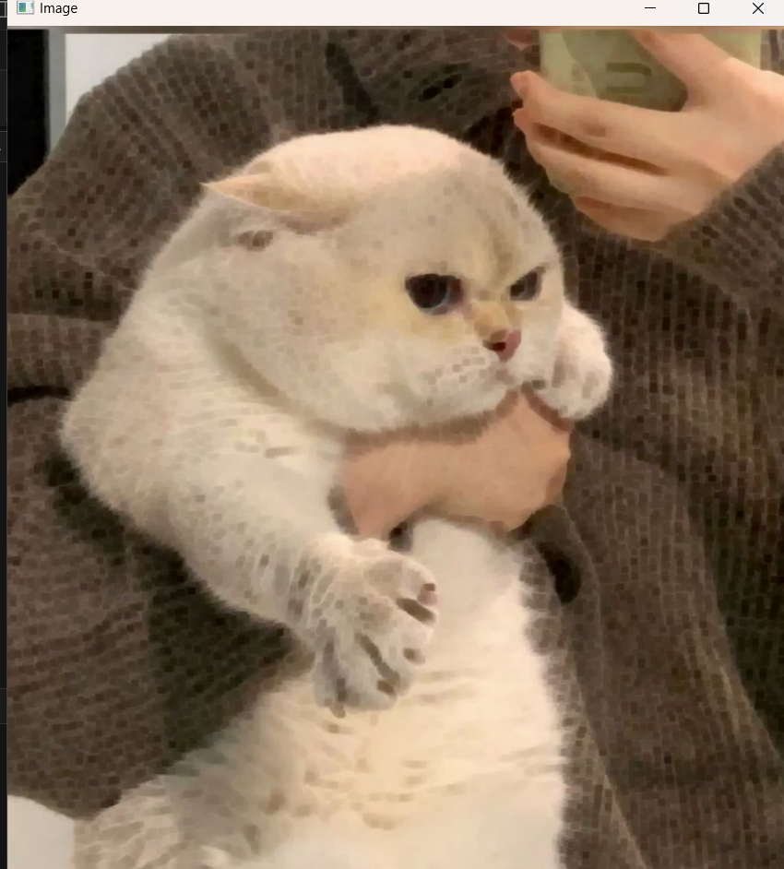

import cv2

import numpy as np

image = cv2.imread("C:\\Users\\eshaa\\OneDrive\\Desktop\\ewww\\car2.jpg")

cv2.imshow('Original Image', image)

cv2.waitKey(0)

# Gaussian Blur

Gaussian = cv2.GaussianBlur(image, (7, 7), 0)

cv2.imshow('Gaussian Blurring', Gaussian)

cv2.waitKey(0)

# Median Blur

median = cv2.medianBlur(image, 5)

cv2.imshow('Median Blurring', median)

cv2.waitKey(0)

# Bilateral Blur

bilateral = cv2.bilateralFilter(image, 9, 75, 75)

cv2.imshow('Bilateral Blurring', bilateral)

cv2.waitKey(0)

cv2.destroyAllWindows()

**OUTPUT:**

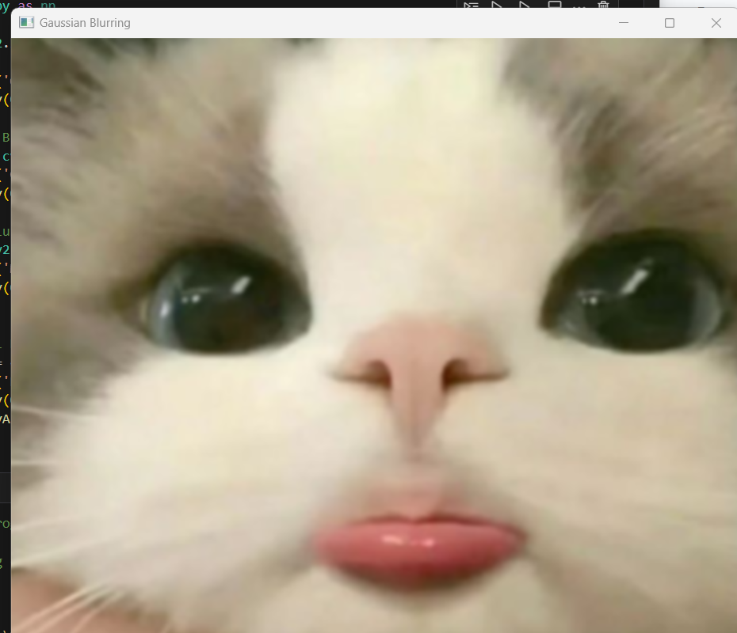

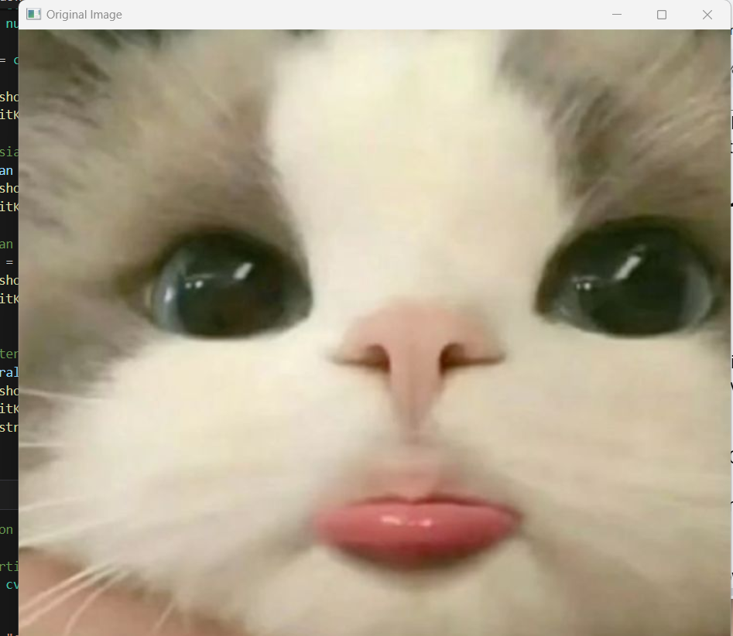

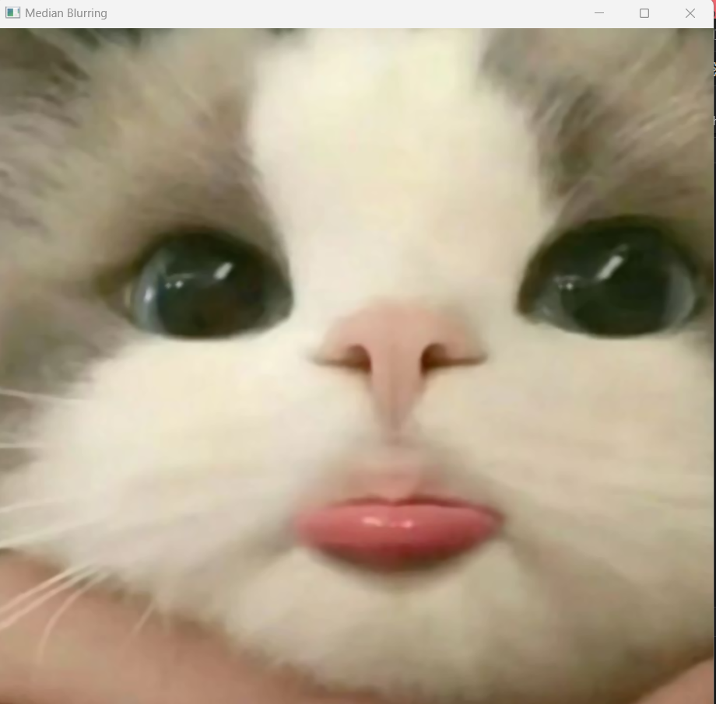

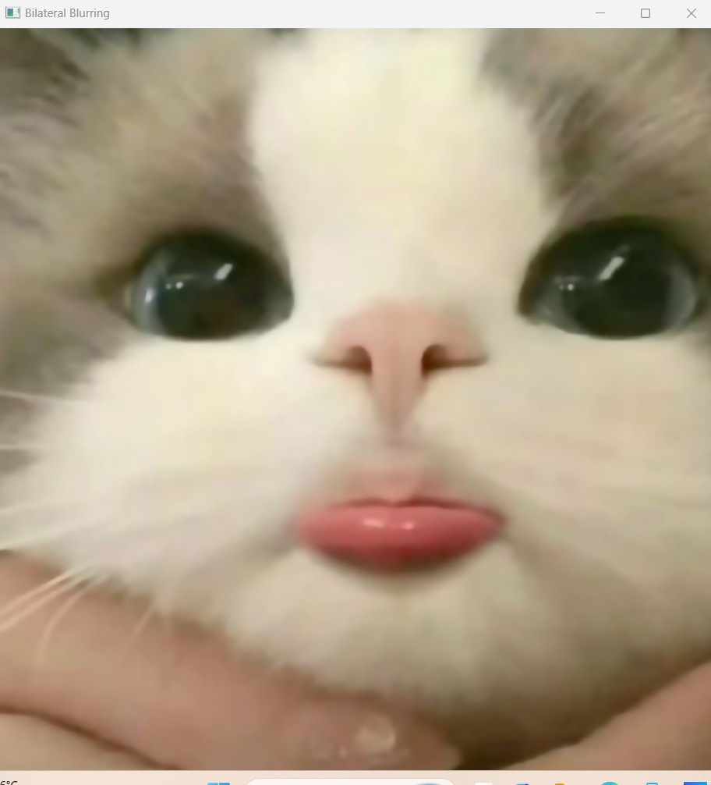

# importing cv2

import cv2

# path

path = "C:\\Users\\eshaa\\OneDrive\\Desktop\\ewww\\car.jpg"

# Reading an image in default mode

image = cv2.imread(path)

# Window name in which image is displayed

window_name = 'Image'

# Using cv2.copyMakeBorder() method

image = cv2.copyMakeBorder(image, 10, 10, 10, 10, cv2.BORDER_CONSTANT, None, value = 0)

# Displaying the image

cv2.imshow(window_name, image)

**Output:**

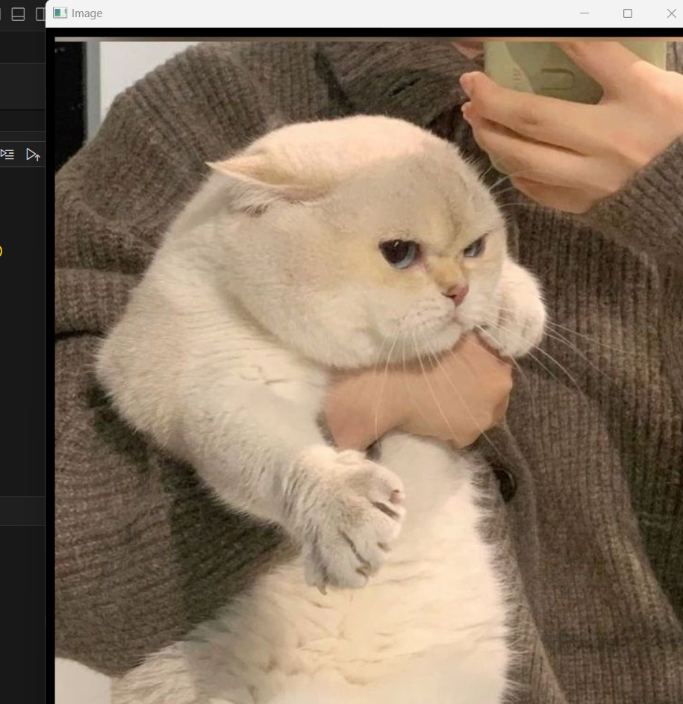

import cv2

# Load the input image

image = cv2.imread("C:\\Users\\eshaa\\OneDrive\\Desktop\\ewww\\car.jpg")

cv2.imshow('Original', image)

cv2.waitKey(0)

# Use the cvtColor() function to grayscale the image

gray_image = cv2.cvtColor(image, cv2.COLOR_BGR2GRAY)

cv2.imshow('Grayscale', gray_image)

cv2.waitKey(0)

# Window shown waits for any key pressing event

cv2.destroyAllWindows()

**Output:**

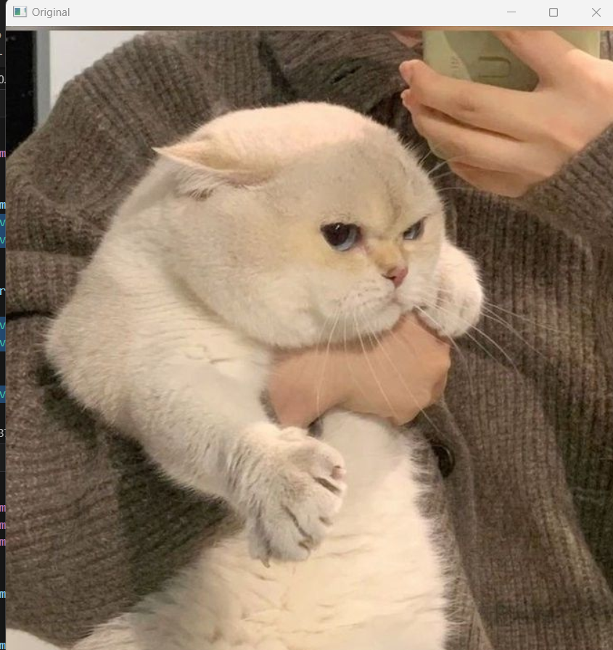

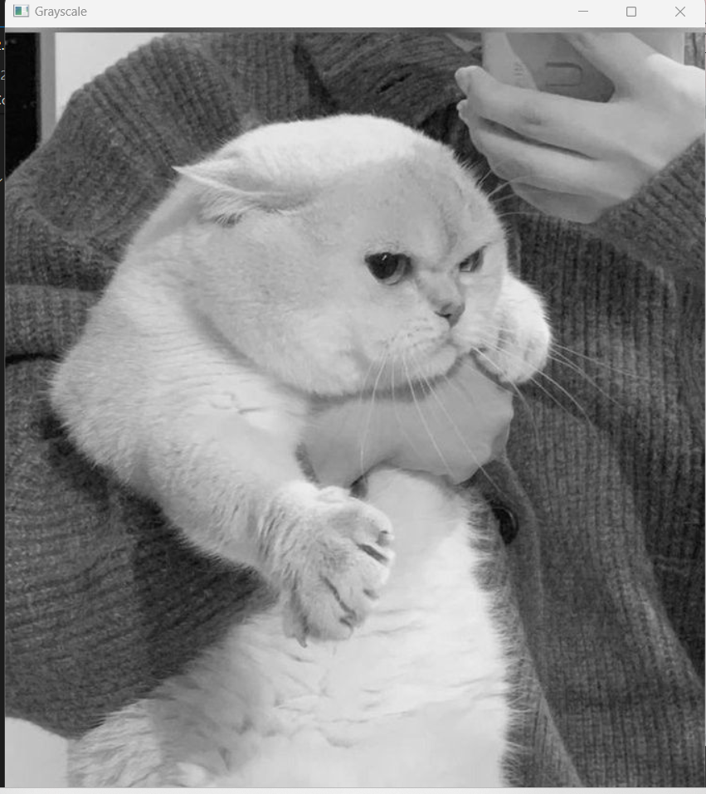

import cv2

import numpy as np

import matplotlib.pyplot as plt

# Load the image

image = cv2.imread("car2.jpg")

# Convert BGR image to RGB

image_rgb = cv2.cvtColor(image, cv2.COLOR_BGR2RGB)

# Define the scale factor

# Increase the size by 3 times

scale_factor_1 = 3.0

# Decrease the size by 3 times

scale_factor_2 = 1/3.0

# Get the original image dimensions

height, width = image_rgb.shape[:2]

# Calculate the new image dimensions

new_height = int(height * scale_factor_1)

new_width = int(width * scale_factor_1)

# Resize the image

zoomed_image = cv2.resize(src =image_rgb,

dsize=(new_width, new_height),

interpolation=cv2.INTER_CUBIC)

# Calculate the new image dimensions

new_height1 = int(height * scale_factor_2)

new_width1 = int(width * scale_factor_2)

# Scaled image

scaled_image = cv2.resize(src= image_rgb,

dsize =(new_width1, new_height1),

interpolation=cv2.INTER_AREA)

# Create subplots

fig, axs = plt.subplots(1, 3, figsize=(10, 4))

# Plot the original image

axs[0].imshow(image_rgb)

axs[0].set_title('Original Image Shape:'+str(image_rgb.shape))

# Plot the Zoomed Image

axs[1].imshow(zoomed_image)

axs[1].set_title('Zoomed Image Shape:'+str(zoomed_image.shape))

# Plot the Scaled Image

axs[2].imshow(scaled_image)

axs[2].set_title('Scaled Image Shape:'+str(scaled_image.shape))

# Remove ticks from the subplots

for ax in axs:

ax.set_xticks([])

ax.set_yticks([])

# Display the subplots

plt.tight_layout()

plt.show()

**Output:**

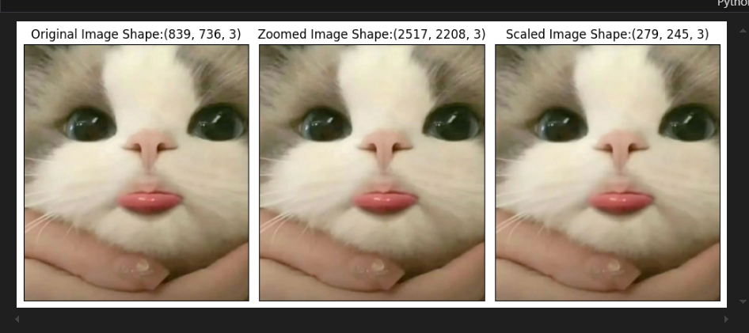

import cv2

import numpy as np

# Reading the input image

img = cv2.imread('car2.jpg', 0)

# Taking a matrix of size 5 as the kernel

kernel = np.ones((5, 5), np.uint8)

img_erosion = cv2.erode(img, kernel, iterations=1)

img_dilation = cv2.dilate(img, kernel, iterations=1)

cv2.imshow('Input', img)

cv2.imshow('Erosion', img_erosion)

cv2.imshow('Dilation', img_dilation)

cv2.waitKey(0)

**Output:**

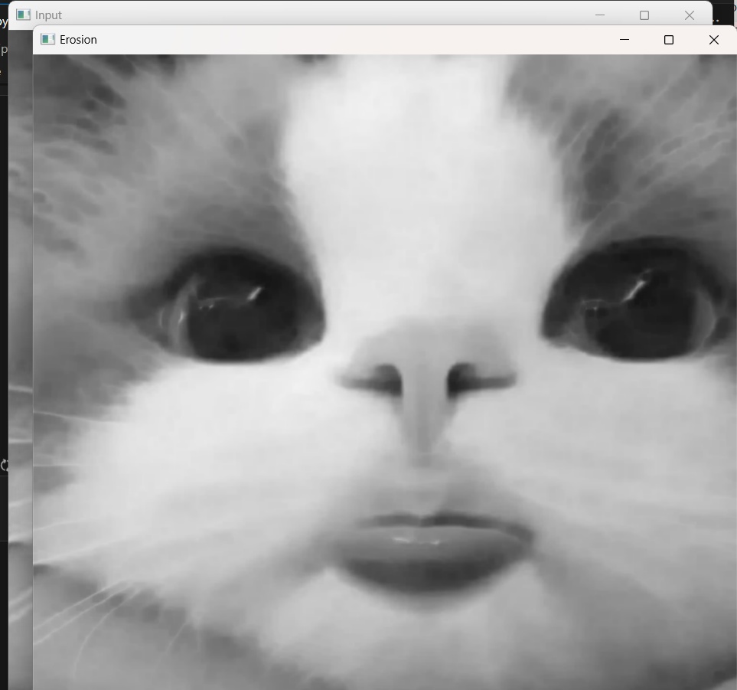

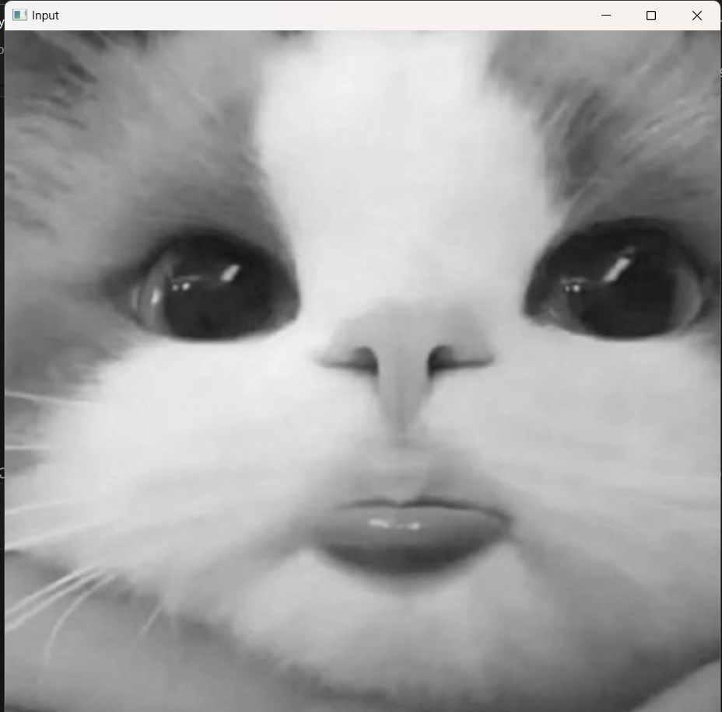

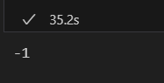

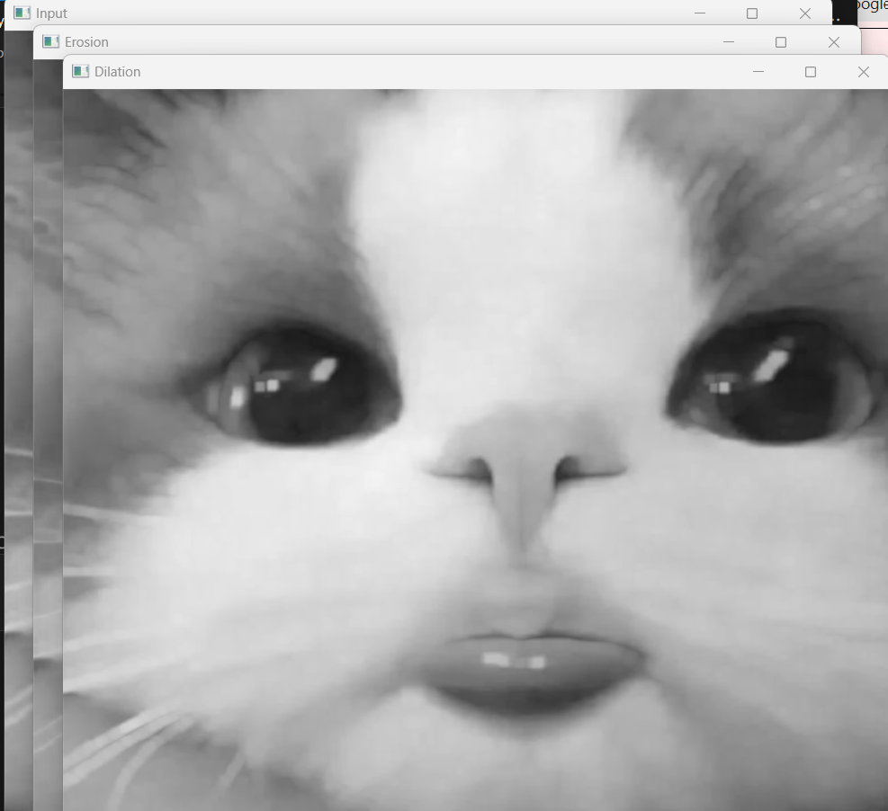

import cv2

from matplotlib import pyplot as plt

img = cv2.imread('car.jpg',0)

# alternative way to find histogram of an image

plt.hist(img.ravel(),256,[0,256])

plt.show()

**Output:**

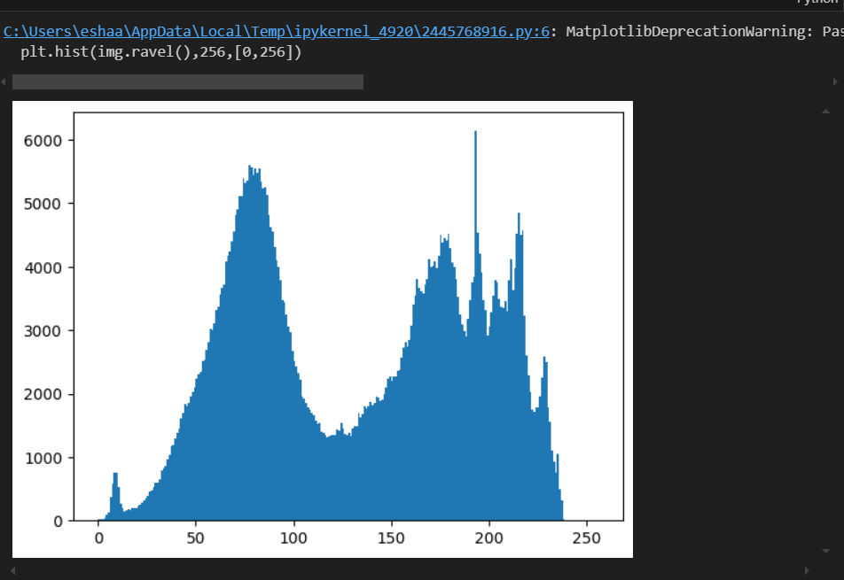

# import Opencv

import cv2

# import Numpy

import numpy as np

# read a image using imread

img = cv2.imread('C:\\Users\\eshaa\\OneDrive\\Desktop\\ewww\\car3.jpg', 0)

# creating a Histograms Equalization

# of a image using cv2.equalizeHist()

equ = cv2.equalizeHist(img)

# stacking images side-by-side

res = np.hstack((img, equ))

# show image input vs output

cv2.imshow('image', res)

cv2.waitKey(0)

cv2.destroyAllWindows()

**Output:**

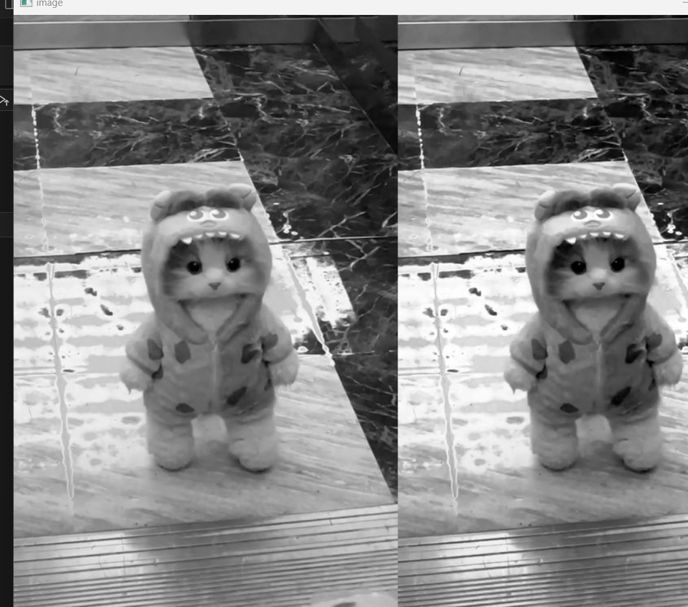

# Python program to illustrate

# simple thresholding type on an image

# organizing imports

import cv2

import numpy as np

# path to input image is specified and

# image is loaded with imread command

image1 = cv2.imread('car3.jpg')

img = cv2.cvtColor(image1, cv2.COLOR_BGR2GRAY)

ret, thresh1 = cv2.threshold(img, 120, 255, cv2.THRESH_BINARY)

ret, thresh2 = cv2.threshold(img, 120, 255, cv2.THRESH_BINARY_INV)

ret, thresh3 = cv2.threshold(img, 120, 255, cv2.THRESH_TRUNC)

ret, thresh4 = cv2.threshold(img, 120, 255, cv2.THRESH_TOZERO)

ret, thresh5 = cv2.threshold(img, 120, 255, cv2.THRESH_TOZERO_INV)

cv2.imshow('Binary Threshold', thresh1)

cv2.imshow('Binary Threshold Inverted', thresh2)

cv2.imshow('Truncated Threshold', thresh3)

cv2.imshow('Set to 0', thresh4)

cv2.imshow('Set to 0 Inverted', thresh5)

# De-allocate any associated memory usage

if cv2.waitKey(0) & 0xff == 27:

cv2.destroyAllWindows()

**Output:**

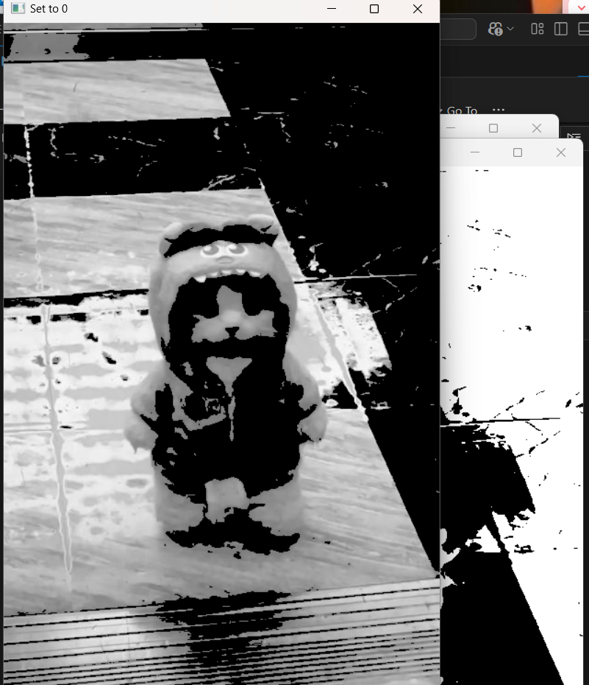

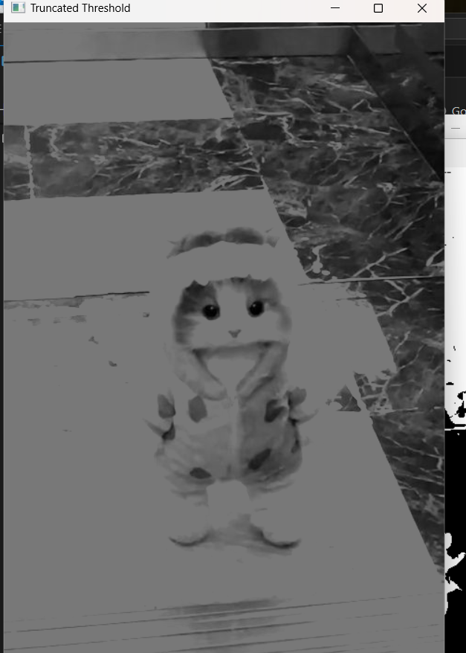

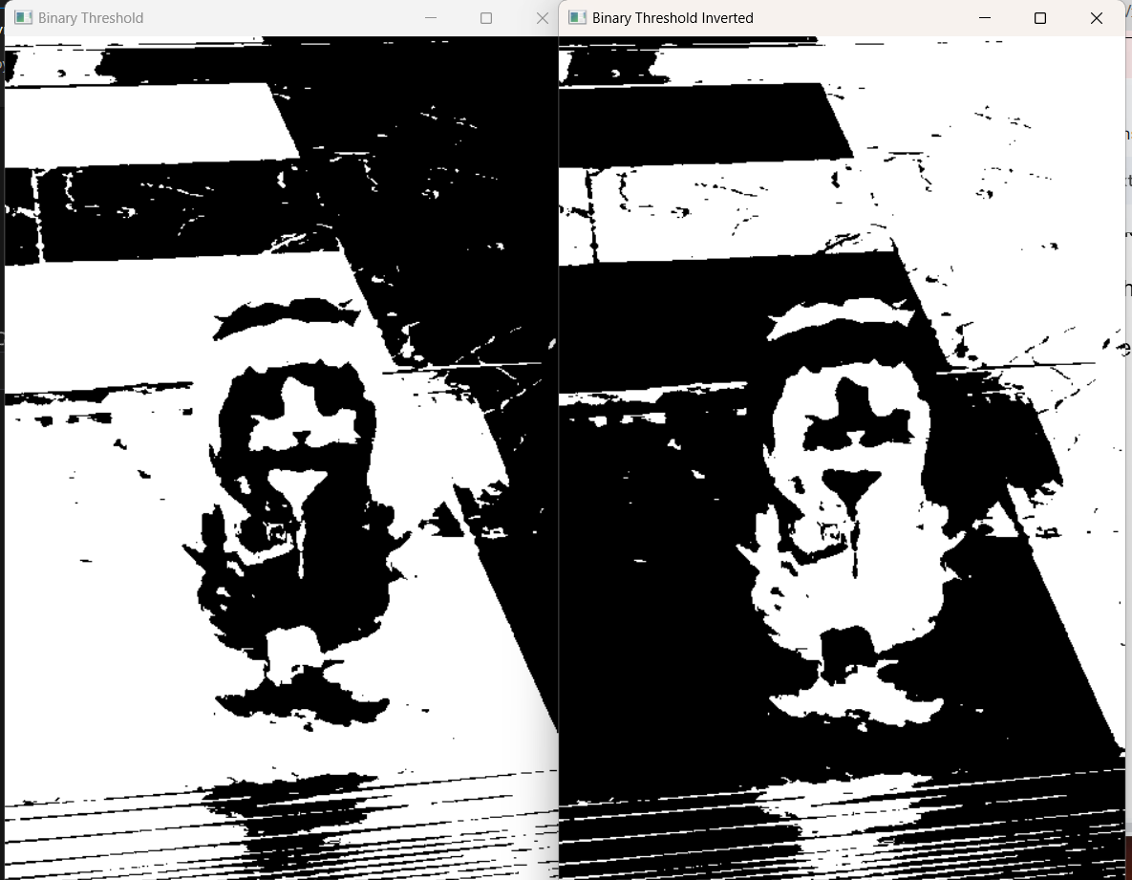

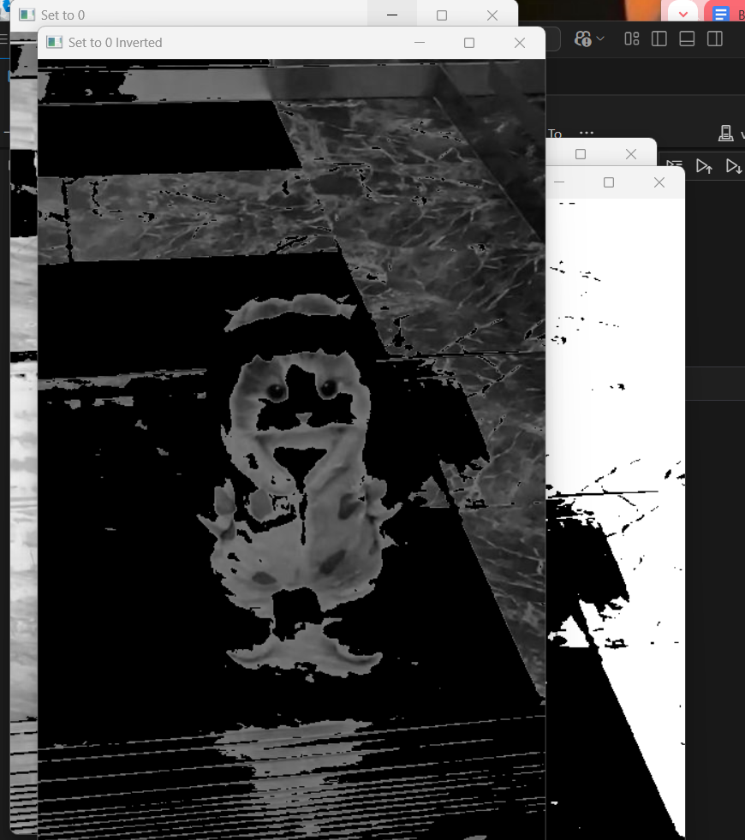

import cv2

# path

path = 'C:\\Users\\eshaa\\OneDrive\\Desktop\\ewww\\car3.jpg'

# Reading an image in default mode

src = cv2.imread(path)

# Window name in which image is displayed

window_name = 'Image'

# Using cv2.cvtColor() method

# Using cv2.COLOR_BGR2GRAY color space

# conversion code

image = cv2.cvtColor(src, cv2.COLOR_BGR2GRAY )

# Displaying the image

cv2.imshow(window_name, image)

**Output:**

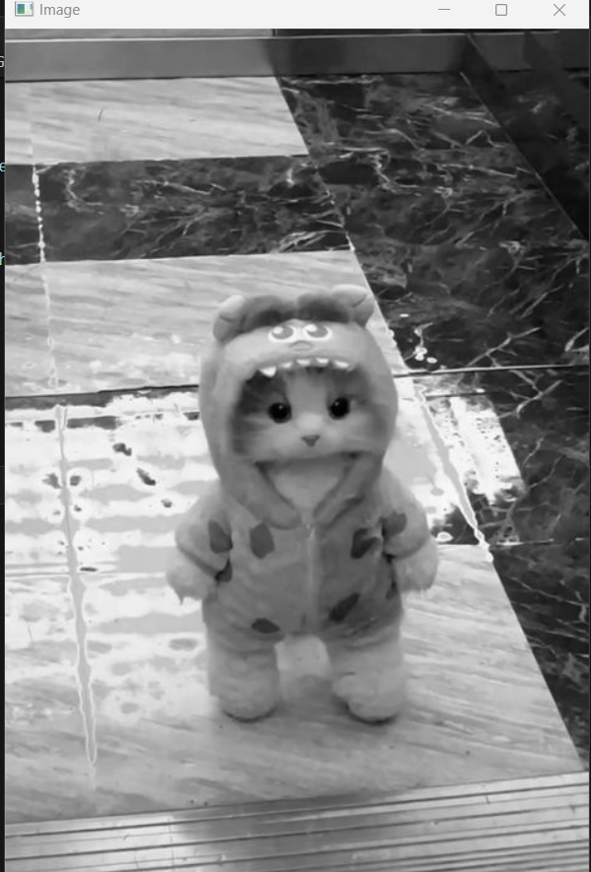

import numpy as np

import cv2

from matplotlib import pyplot as plt

# Reading image from folder where it is stored

img = cv2.imread('car.jpg')

# denoising of image saving it into dst image

dst = cv2.fastNlMeansDenoisingColored(img, None, 10, 10, 7, 15)

# Plotting of source and destination image

plt.subplot(121), plt.imshow(img)

plt.subplot(122), plt.imshow(dst)

plt.show()

**Output:**

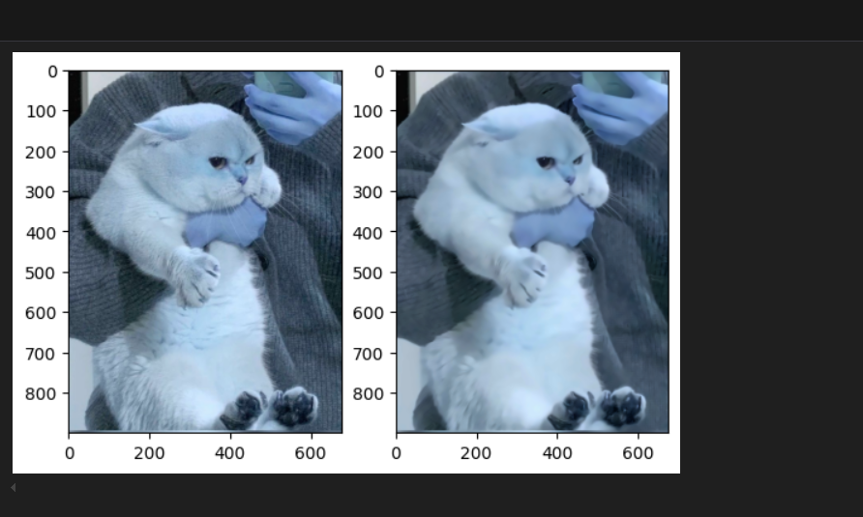

import cv2

import matplotlib.pyplot as plt

# reads image as RGB

img = cv2.imread('car3.jpg')

# shows the image

plt.imshow(img)

**Output:**

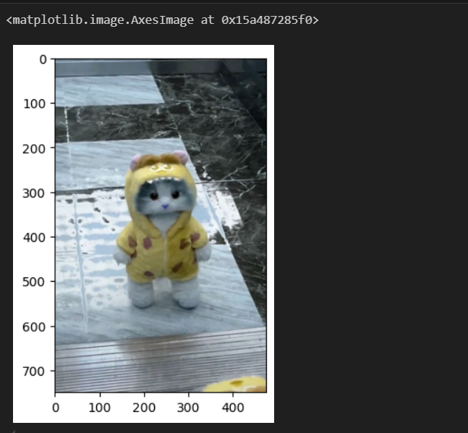

import cv2

import numpy as np

image = cv2.imread('car2.jpg')

# Store height and width of the image

height, width = image.shape[:2]

quarter_height, quarter_width = height / 4, width / 4

T = np.float32([[1, 0, quarter_width], [0, 1, quarter_height]])

# We use warpAffine to transform

# the image using the matrix, T

img_translation = cv2.warpAffine(image, T, (width, height))

cv2.imshow("Originalimage", image)

cv2.imshow('Translation', img_translation)

cv2.waitKey()

cv2.destroyAllWindows()

**Output:**

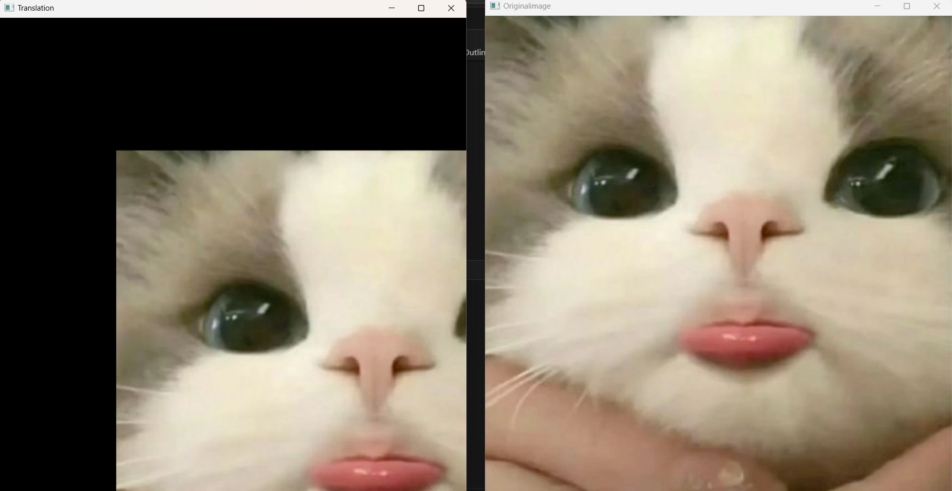

import cv2

import matplotlib.pyplot as plt

img = cv2.imread("car2.jpg")

layer = img.copy()

for i in range(4):

plt.subplot(2, 2, i + 1)

# using pyrDown() function

layer = cv2.pyrDown(layer)

plt.imshow(layer)

cv2.imshow("str(i)", layer)

cv2.waitKey(0)

cv2.destroyAllWindows()

**Output:**

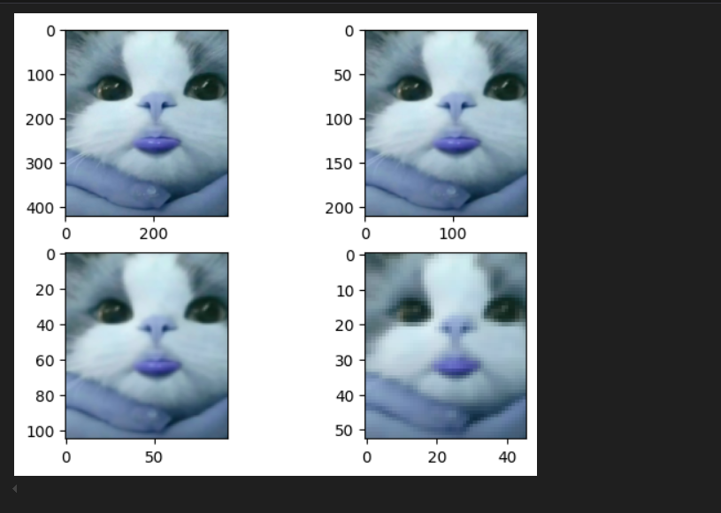

**2.3**

import cv2

import numpy as np

img = cv2.imread('car.jpg')

gray = cv2.cvtColor(img, cv2.COLOR_BGR2GRAY)

edges = cv2.Canny(gray, 50, 150, apertureSize=3)

# This returns an array of r and theta values

lines = cv2.HoughLines(edges, 1, np.pi/180, 200)

for r_theta in lines:

arr = np.array(r_theta[0], dtype=np.float64)

r, theta = arr

# Stores the value of cos(theta) in a

a = np.cos(theta)

b = np.sin(theta)

x0 = a*r

y0 = b*r

x1 = int(x0 + 1000*(-b))

y1 = int(y0 + 1000*(a))

x2 = int(x0 - 1000*(-b))

y2 = int(y0 - 1000*(a))

cv2.line(img, (x1, y1), (x2, y2), (0, 0, 255), 2)

cv2.imwrite('linesDetected.jpg', img)

**OUTPUT:**

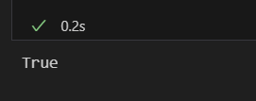

import cv2

import numpy as np

# Read image.

img = cv2.imread('car2.jpg', cv2.IMREAD_COLOR)

# Convert to grayscale.

gray = cv2.cvtColor(img, cv2.COLOR_BGR2GRAY)

# Blur using 3 * 3 kernel.

gray_blurred = cv2.blur(gray, (3, 3))

# Apply Hough transform on the blurred image.

detected_circles = cv2.HoughCircles(gray_blurred,

cv2.HOUGH_GRADIENT, 1, 20, param1 = 50,

param2 = 30, minRadius = 1, maxRadius = 40)

# Draw circles that are detected.

if detected_circles is not None:

# Convert the circle parameters a, b and r to integers.

detected_circles = np.uint16(np.around(detected_circles))

for pt in detected_circles[0, :]:

a, b, r = pt[0], pt[1], pt[2]

# Draw the circumference of the circle.

cv2.circle(img, (a, b), r, (0, 255, 0), 2)

# Draw a small circle (of radius 1) to show the center.

cv2.circle(img, (a, b), 1, (0, 0, 255), 3)

cv2.imshow("Detected Circle", img)

cv2.waitKey(0)

**OUTPUT:**

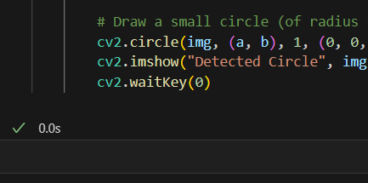**(IDK WHERE ITS OUTPUT IS )insert cry emoji :(**

**import numpy as np**

import cv2

from matplotlib import pyplot as plt

img = cv2.imread('chess.jpg')

gray = cv2.cvtColor(img, cv2.COLOR_BGR2GRAY)

corners = cv2.goodFeaturesToTrack(gray, 27, 0.01, 10)

corners = corners.astype(np.int64) # or np.int_

for i in corners:

x, y = i.ravel()

cv2.circle(img, (x, y), 3, 255, -1)

plt.imshow(img), plt.show()

**OUTPUT:**

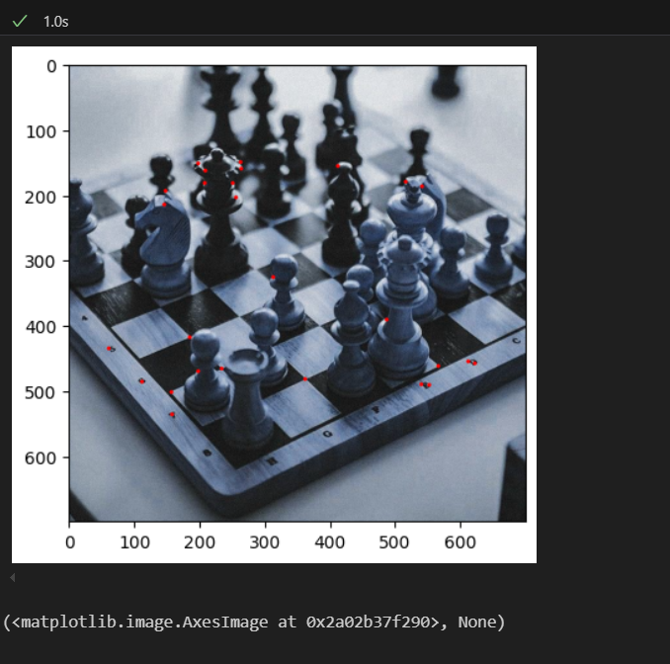

import cv2

import numpy as np

import matplotlib.pyplot as plt

%matplotlib inline

img = cv2.imread('chess.jpg')

gray_img = cv2.cvtColor(img, cv2.COLOR_BGR2GRAY)

corners = cv2.goodFeaturesToTrack(gray_img, 100, 0.01, 10)

corners = corners.astype(np.int64) # or np.int_

for i in corners:

x, y = i.ravel()

cv2.circle(img, (x, y), 3, (255, 0, 0), -1)

plt.imshow(img)

if cv2.waitKey(0) & 0xff == 27:

cv2.destroyAllWindows()

**Output:**

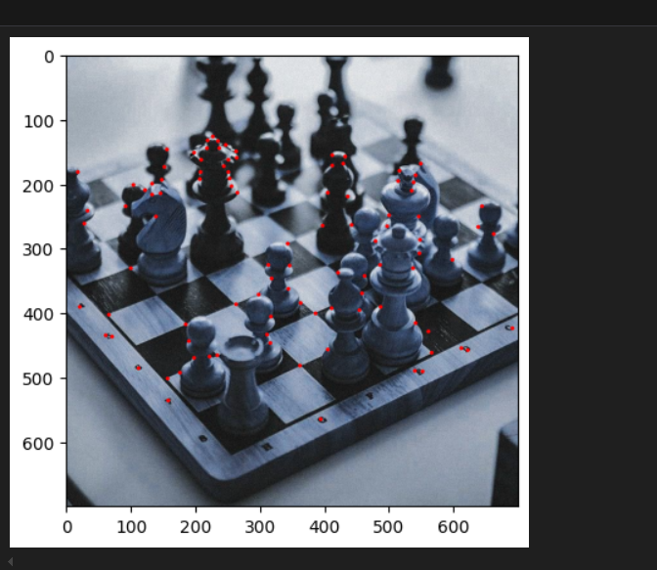

import cv2

import numpy as np

image = cv2.imread('car3.jpg')

# convert the input image into

# grayscale color space

operatedImage = cv2.cvtColor(image, cv2.COLOR_BGR2GRAY)

# modify the data type

# setting to 32-bit floating point

operatedImage = np.float32(operatedImage)

dest = cv2.cornerHarris(operatedImage, 2, 5, 0.07)

# Results are marked through the dilated corners

dest = cv2.dilate(dest, None)

image[dest > 0.01 * dest.max()]=[0, 0, 255]

# the window showing output image with corners

cv2.imshow('Image with Borders', image)

# De-allocate any associated memory usage

if cv2.waitKey(0) & 0xff == 27:

cv2.destroyAllWindows()

**Output:**

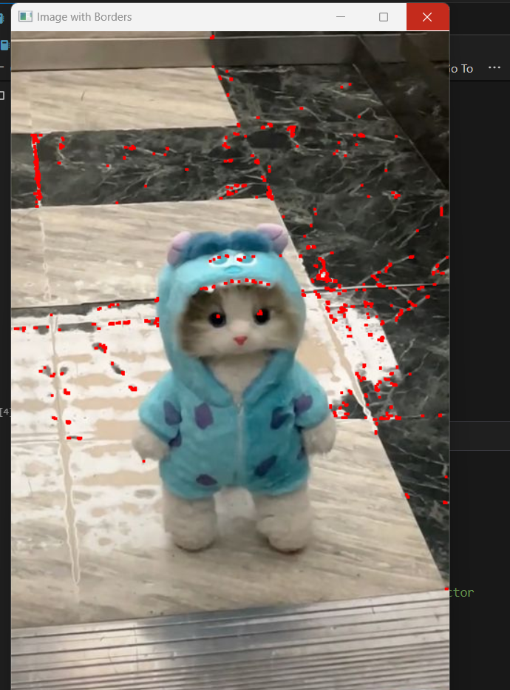

import cv2

import numpy as np

# Load image

image = cv2.imread('circles.jpg', 0)

# Set our filtering parameters

# Initialize parameter setting using cv2.SimpleBlobDetector

params = cv2.SimpleBlobDetector_Params()

# Set Area filtering parameters

params.filterByArea = True

params.minArea = 100

# Set Circularity filtering parameters

params.filterByCircularity = True

params.minCircularity = 0.9

# Set Convexity filtering parameters

params.filterByConvexity = True

params.minConvexity = 0.2

# Set inertia filtering parameters

params.filterByInertia = True

params.minInertiaRatio = 0.01

# Create a detector with the parameters

detector = cv2.SimpleBlobDetector_create(params)

# Detect blobs

keypoints = detector.detect(image)

# Draw blobs on our image as red circles

blank = np.zeros((1, 1))

blobs = cv2.drawKeypoints(image, keypoints, blank, (0, 0, 255),

cv2.DRAW_MATCHES_FLAGS_DRAW_RICH_KEYPOINTS)

number_of_blobs = len(keypoints)

text = "Number of Circular Blobs: " + str(len(keypoints))

cv2.putText(blobs, text, (20, 550),

cv2.FONT_HERSHEY_SIMPLEX, 1, (0, 100, 255), 2)

# Show blobs

cv2.imshow("Filtering Circular Blobs Only", blobs)

cv2.waitKey(0)

cv2.destroyAllWindows()

**Output:**

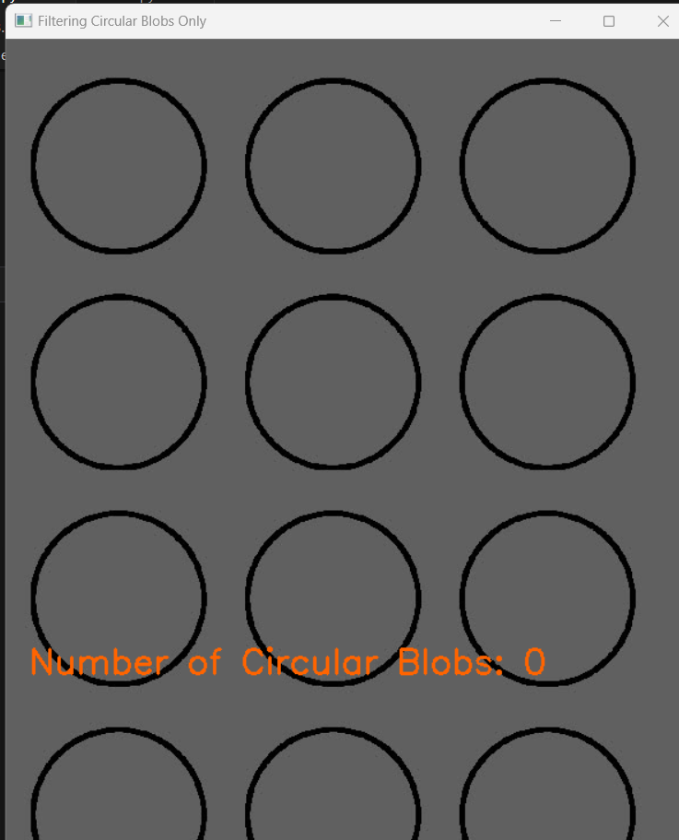

import numpy as np

import imutils

import cv2

field_threshold = { "prev_policy_no" : 0.7,

"address" : 0.6,

}

# Function to Generate bounding

# boxes around detected fields

def getBoxed(img, img_gray, template, field_name = "policy_no"):

w, h = template.shape[::-1]

# Apply template matching

res = cv2.matchTemplate(img_gray, template,

cv2.TM_CCOEFF_NORMED)

hits = np.where(res >= field_threshold[field_name])

# Draw a rectangle around the matched region.

for pt in zip(*hits[::-1]):

cv2.rectangle(img, pt, (pt[0] + w, pt[1] + h),

(0, 255, 255), 2)

y = pt[1] - 10 if pt[1] - 10 > 10 else pt[1] + h + 20

cv2.putText(img, field_name, (pt[0], y),

cv2.FONT_HERSHEY_SIMPLEX, 0.8, (0, 0, 255), 1)

return img

# Driver Function

if __name__ == '__main__':

# Read the original document image

img = cv2.imread('doc1.png')

# 3-d to 2-d conversion

img_gray = cv2.cvtColor(img, cv2.COLOR_BGR2GRAY)

# Field templates

template_add = cv2.imread('doc1.png', 0)

template_prev = cv2.imread('doc1.png', 0)

img = getBoxed(img.copy(), img_gray.copy(),

template_add, 'address')

img = getBoxed(img.copy(), img_gray.copy(),

template_prev, 'prev_policy_no')

cv2.imshow('Detected', img)

**Output:**

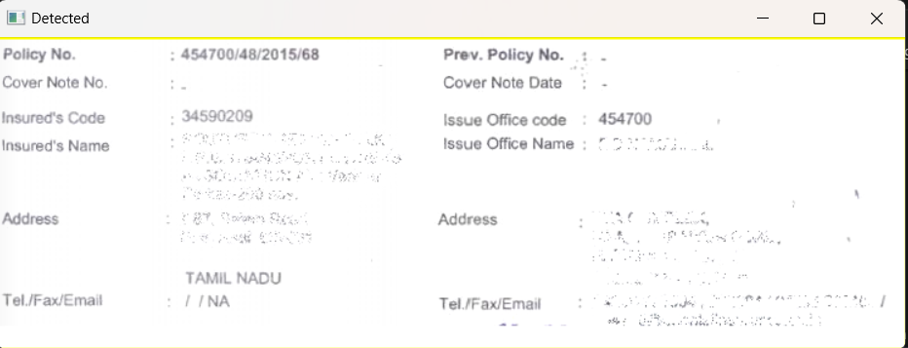

**2.4**

**(ALLAH MAF KARY AISA TASK NA DIA KARAIN SIR ITNA LAMBA TASK NAI THA JITNI LAMBI YE WORD FILE BANANI PARH GAE)**

import cv2

path = 'C:\\Users\\eshaa\\OneDrive\\Desktop\\ewww\\chess.jpg'

image = cv2.imread(path)

# Window name in which image is displayed

window_name = 'Image'

start_point = (0, 0)

end_point = (250, 250)

# Green color in BGR

color = (0, 255, 0)

# Line thickness of 9 px

thickness = 9

image = cv2.line(image, start_point, end_point, color, thickness)

# Displaying the image

cv2.imshow(window_name, image)

**Output:**

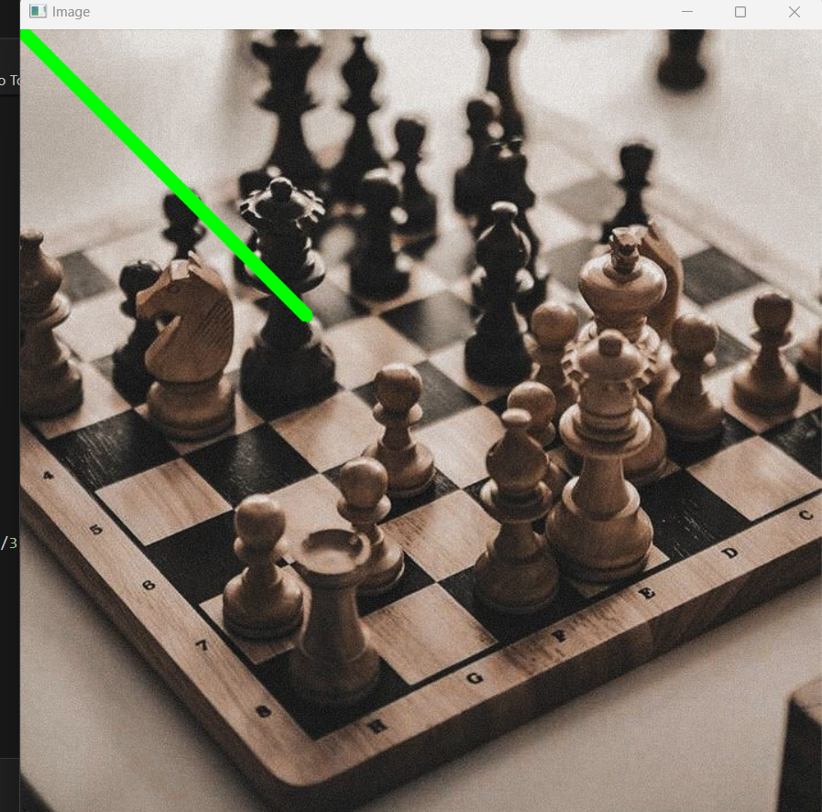

import cv2

path = 'C:\\Users\\eshaa\\OneDrive\\Desktop\\ewww\\chess.jpg'

# Reading an image in default mode

image = cv2.imread(path)

window_name = 'Image'

start_point = (0, 0)

# End coordinate

end_point = (200, 200)

# Green color in BGR

color = (0, 255, 0)

# Line thickness of 9 px

thickness = 9

image = cv2.arrowedLine(image, start_point, end_point,

color, thickness)

# Displaying the image

cv2.imshow(window_name, image)

**Output:**

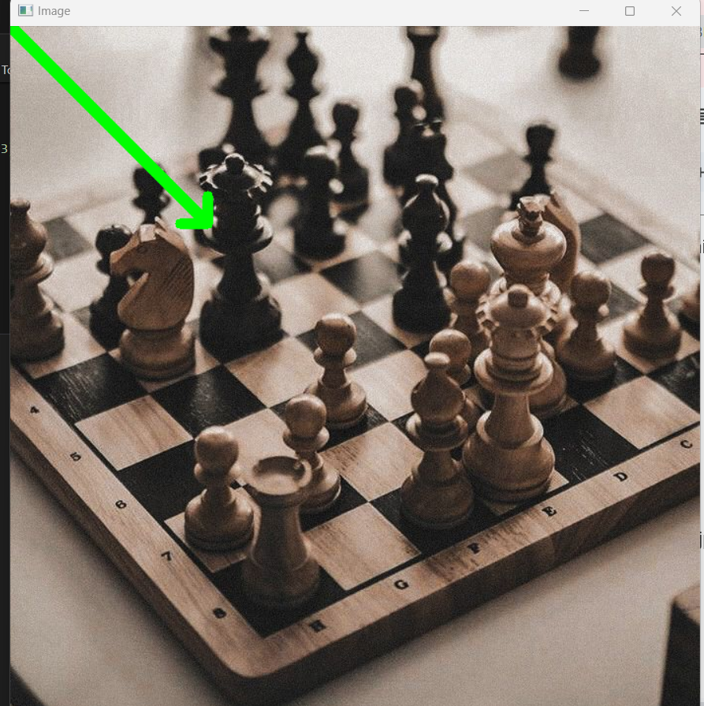

import cv2

# path

path = 'C:\\Users\\eshaa\\OneDrive\\Desktop\\ewww\\chess.jpg'

# Reading an image in default mode

image = cv2.imread(path)

# Window name in which image is displayed

window_name = 'Image'

center_coordinates = (120, 100)

axesLength = (100, 50)

angle = 0

startAngle = 0

endAngle = 360

# Red color in BGR

color = (0, 0, 255)

# Line thickness of 5 px

thickness = 5

# Using cv2.ellipse() method

# Draw a ellipse with red line borders of thickness of 5 px

image = cv2.ellipse(image, center_coordinates, axesLength,

angle, startAngle, endAngle, color, thickness)

# Displaying the image

cv2.imshow(window_name, image)

**Output:**

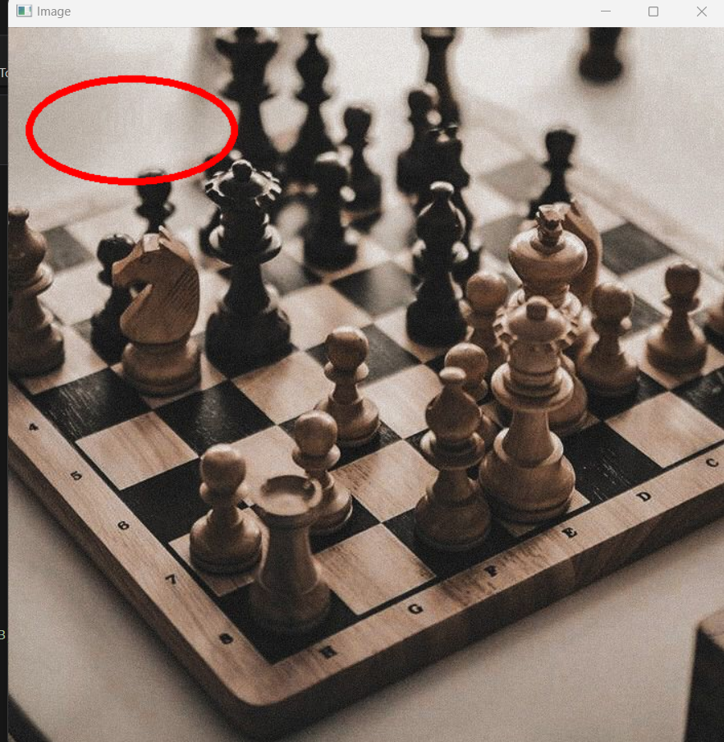

import cv2

path = 'C:\\Users\\eshaa\\OneDrive\\Desktop\\ewww\\chess.jpg'

# Reading an image in default mode

image = cv2.imread(path)

# Window name in which image is displayed

window_name = 'Image'

# Center coordinates

center_coordinates = (120, 50)

# Radius of circle

radius = 20

# Blue color in BGR

color = (255, 0, 0)

# Line thickness of 2 px

thickness = 2

# Using cv2.circle() method

# Draw a circle with blue line borders of thickness of 2 px

image = cv2.circle(image, center_coordinates, radius, color, thickness)

# Displaying the image

cv2.imshow(window_name, image)

**Output:**

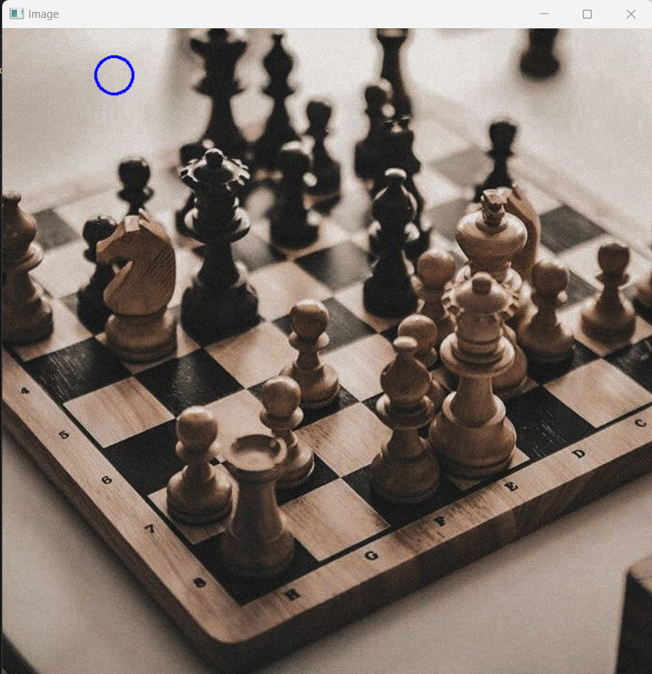

import cv2

path = 'C:\\Users\\eshaa\\OneDrive\\Desktop\\ewww\\car3.jpg'

# Reading an image in default mode

image = cv2.imread(path)

# Window name in which image is displayed

window_name = 'Image'

# Start coordinate, here (5, 5)

# represents the top left corner of rectangle

start_point = (5, 5)

# Ending coordinate, here (220, 220)

# represents the bottom right corner of rectangle

end_point = (220, 220)

# Blue color in BGR

color = (255, 0, 0)

# Line thickness of 2 px

thickness = 2

# Using cv2.rectangle() method

# Draw a rectangle with blue line borders of thickness of 2 px

image = cv2.rectangle(image, start_point, end_point, color, thickness)

# Displaying the image

cv2.imshow(window_name, image)

**Output:**

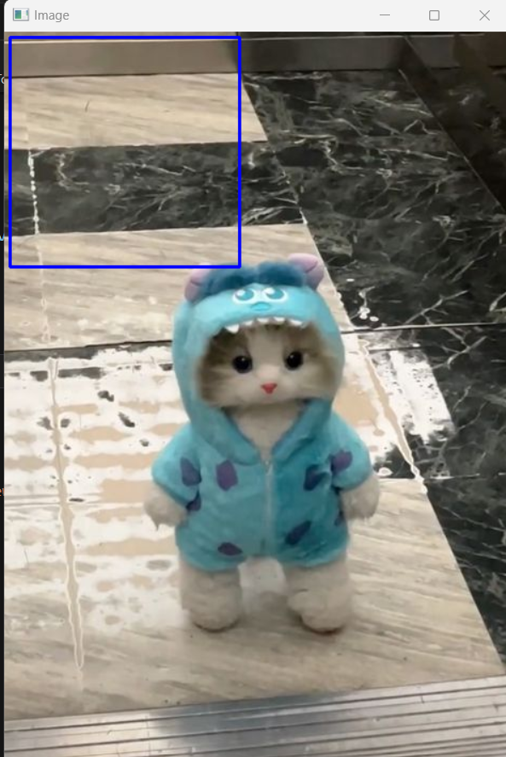

import cv2

path = 'C:\\Users\\eshaa\\OneDrive\\Desktop\\ewww\\car3.jpg'

# Reading an image in default mode

image = cv2.imread(path)

# Window name in which image is displayed

window_name = 'Image'

# font

font = cv2.FONT_HERSHEY_SIMPLEX

# org

org = (50, 50)

# fontScale

fontScale = 1

# Blue color in BGR

color = (255, 0, 0)

# Line thickness of 2 px

thickness = 2

# Using cv2.putText() method

image = cv2.putText(image, 'OpenCV', org, font,

fontScale, color, thickness, cv2.LINE_AA)

# Displaying the image

cv2.imshow(window_name, image)

**Output:**

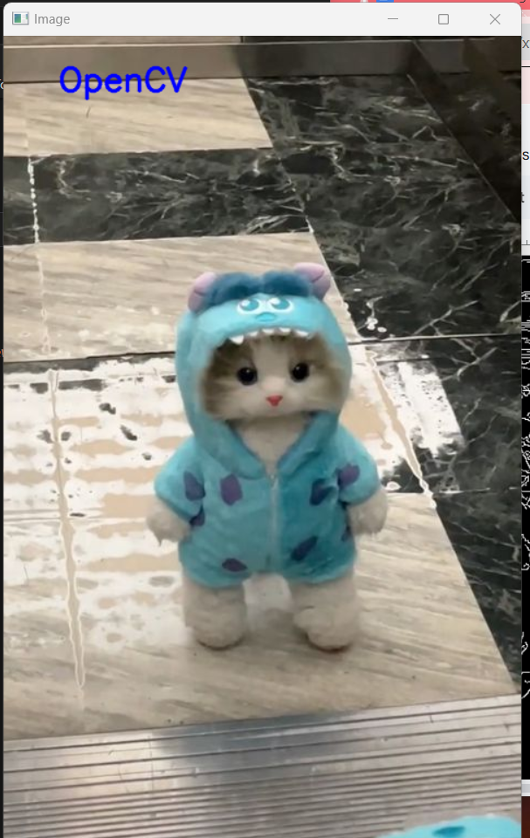

import cv2

import numpy as np

# Let's load a simple image with 3 black squares

image = cv2.imread('C:\\Users\\eshaa\\OneDrive\\Desktop\\ewww\\car3.jpg')

cv2.waitKey(0)

# Grayscale

gray = cv2.cvtColor(image, cv2.COLOR_BGR2GRAY)

# Find Canny edges

edged = cv2.Canny(gray, 30, 200)

cv2.waitKey(0)

# Finding Contours

# Use a copy of the image e.g. edged.copy()

# since findContours alters the image

contours, hierarchy = cv2.findContours(edged,

cv2.RETR_EXTERNAL, cv2.CHAIN_APPROX_NONE)

cv2.imshow('Canny Edges After Contouring', edged)

cv2.waitKey(0)

print("Number of Contours found = " + str(len(contours)))

# Draw all contours

# -1 signifies drawing all contours

cv2.drawContours(image, contours, -1, (0, 255, 0), 3)

cv2.imshow('Contours', image)

cv2.waitKey(0)

cv2.destroyAllWindows()

**Output:**

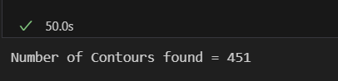

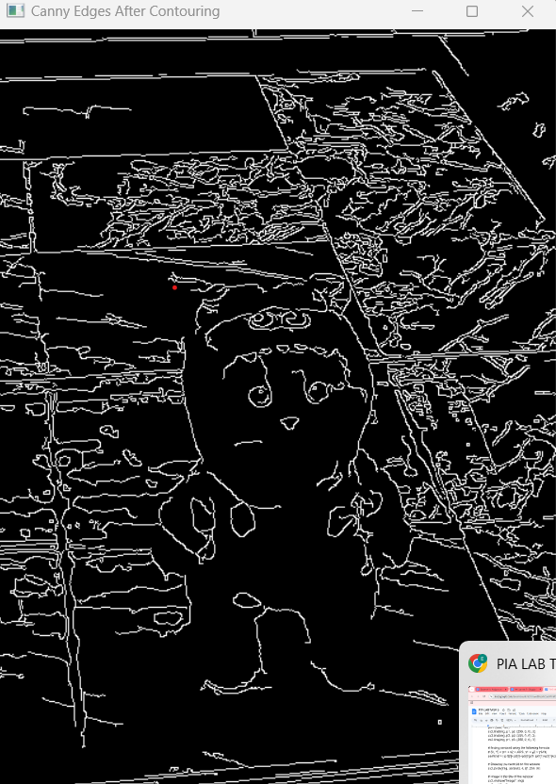

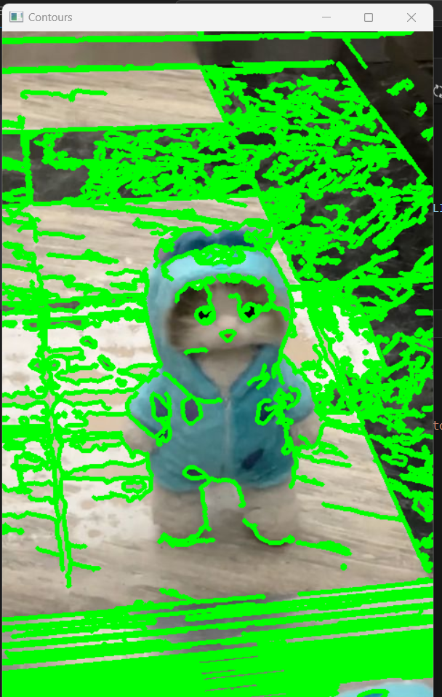

import numpy as np

import cv2

# Width and height of the black window

width = 400

height = 300

# Create a black window of 400 x 300

img = np.zeros((height, width, 3), np.uint8)

# Three vertices(tuples) of the triangle

p1 = (100, 200)

p2 = (50, 50)

p3 = (300, 100)

cv2.line(img, p1, p2, (255, 0, 0), 3)

cv2.line(img, p2, p3, (255, 0, 0), 3)

cv2.line(img, p1, p3, (255, 0, 0), 3)

# finding centroid using the following formula

# (X, Y) = (x1 + x2 + x3//3, y1 + y2 + y3//3)

centroid = ((p1[0]+p2[0]+p3[0])//3, (p1[1]+p2[1]+p3[1])//3)

# Drawing the centroid on the window

cv2.circle(img, centroid, 4, (0, 255, 0))

# image is the title of the window

cv2.imshow("image", img)

cv2.waitKey(0)

**Output:**

